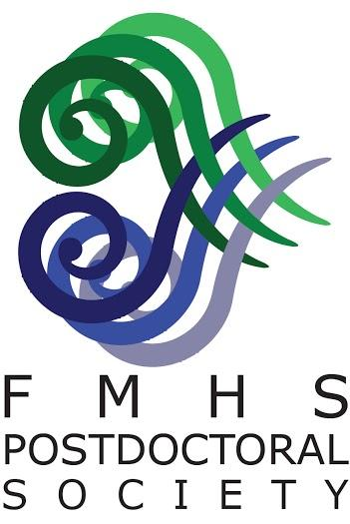
FMHS Postdoctoral Society Travel Grants

The FMHS Postdoctoral Society offers Research Fellows and Senior Research Fellows travel grant awards to assist with costs associated with travel to a scientific conference, meeting or workshop. These awards can be used for domestic or international travel and awardees are chosen based on the scientific merit of the meeting, the specific benefits associated with attending the meeting, and on the level of service contribution made to the University or Faculty during the past 12 months. Funding will go towards travel expenses that must be claimed BEFORE 31st July 2020 for meetings held between 1st January and 30th June 2020.

Estimated funding available⁺ for the Feb 2020 Travel Grant Round to total $4,000:
International travel, up to $1,000 per award
Domestic travel, up to $500 per award

Applicants must meet the following criteria:
- The applicant must be employed by The University of Auckland or UniServices as a Research Fellow or Senior Research Fellow or fixed term lecturer, and Ph.D. qualified at the time of application*.
- The applicant must be the presenting author of an abstract to be presented at a scientific meeting or be attending a meeting or workshop that is of critical value to their scientific career.
- The applicant has not received a FMHS Postdoctoral Society Travel grant in the past 12 months (i.e. in the prior two FMHS Postdoctoral Society funding rounds).
- Preference will be given to applicants who are invited speakers or are combining multiple purposes into one trip.

To apply for FMHS travel grants please provide the following:
Please convert all of the following into a SINGLE PDF document prior to submission
- A one page outline including:
- A brief description of the conference/meeting/ workshop you plan to attend
- The key goals in attending the meeting in terms of benefits to your research career
- A concise travel itinerary, breakdown of travel budget and other funding available or applied for (quotes are NOT required).
- A brief summary of your service contribution to The University of Auckland and/or FMHS over the past 12 months (e.g. committee membership, involvement in voluntary organisations within the university, role in organising seminars, schools outreach)
- The abstract to be presented at the meeting - please indicate whether this has been accepted and whether you have been awarded a poster or oral presentation (or an expected announcement date) including author names
- Your CV (2 page max)
- A completed FMHS Postdoctoral Society Grant coversheet

Submit applications to fmhs-res-fellows@auckland.ac.nz by 5pm on 14th Feb 2020

⁺Funding may be adjusted depending on applications received
*Please contact us if you unsure of your eligibility

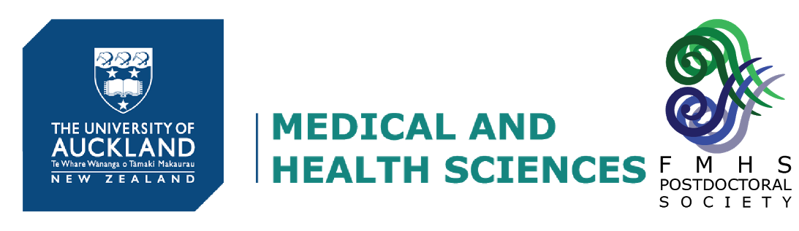
FMHS Postdoctoral Society Travel and Publishing Grants

Please complete the following:
Closing Date: | 14th Feb 2020

Name:
Position:
Department:
Email:
Phone:

Amount Requested:

For Travel Grants: (select one)
Domestic | International

Complete the following:
Name of conference/workshop:
Venue:
Travel Dates:
Abstract Submission:
e.g. Accepted for oral presentation

FMHS PDS Award History:
Have you previously received an FMHS Postdoctoral Society travel or publishing grant?
Y / N – if Y, indicate when:

Applicant
Name | Signature | Date
Mentor/Supervisor
Name | Signature | Date
Head of Department
Name | Signature | Date

Application (1 page maximum, please include a breakdown of travel and accommodation costs or estimated publication costs)

Abstract (conference or journal submission including Author names)
CV (2 pages maximum)

